Week 2 Lab Task
Information Gathering (OSINT)
NIAI NAVTTC — Certified Ethical Hacker (CEH) Course
⚠ Important: I performed actions on UmrahTaxiService.com

▶ Write Your Intelligence Report
Document the following findings in a structured report:
- Who owns the domain? (WHOIS data)
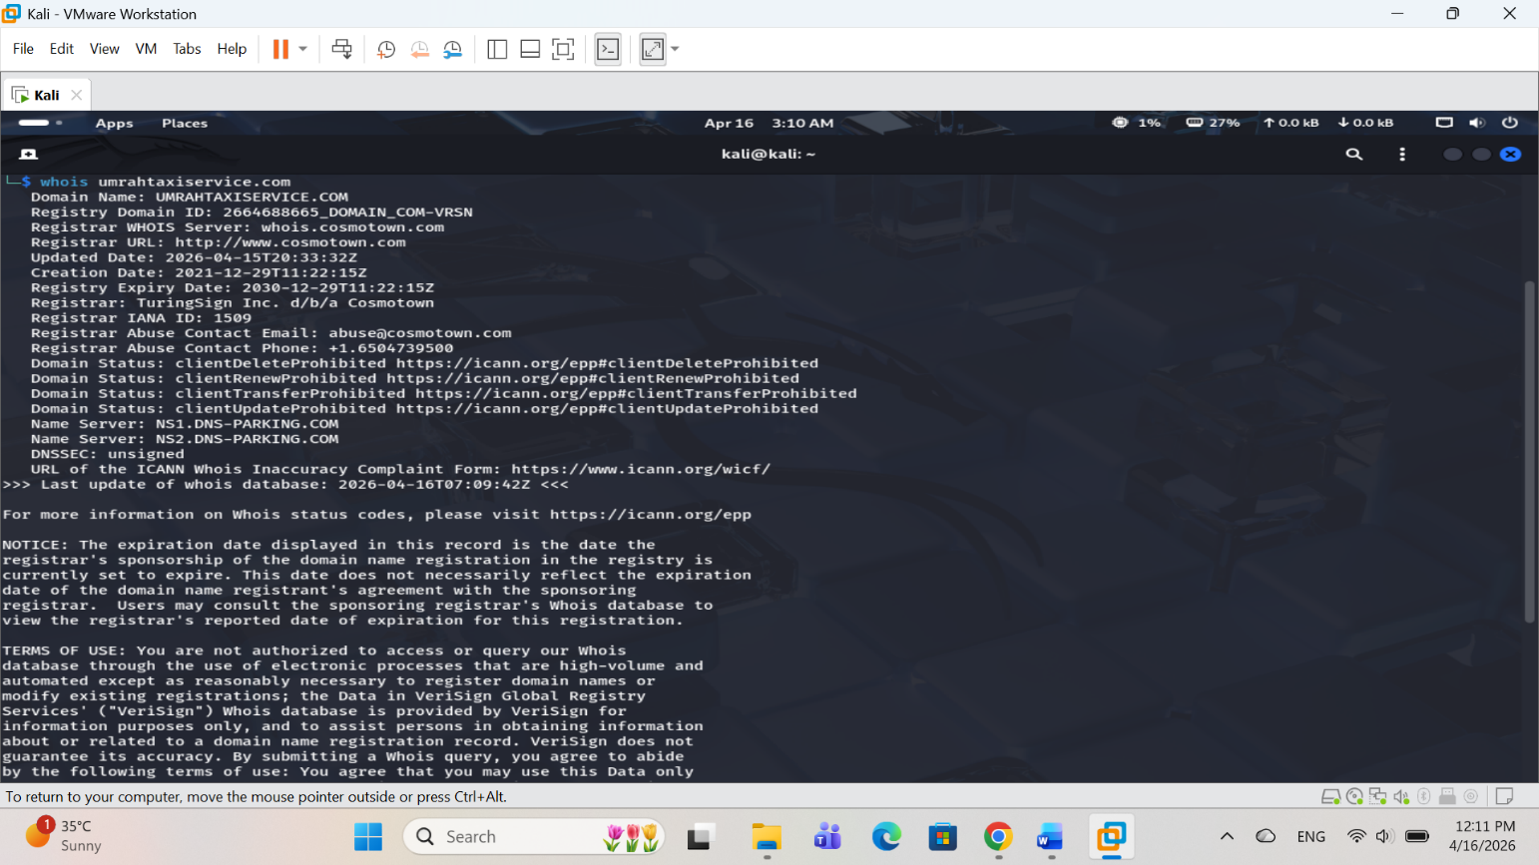
- What IP addresses are associated?
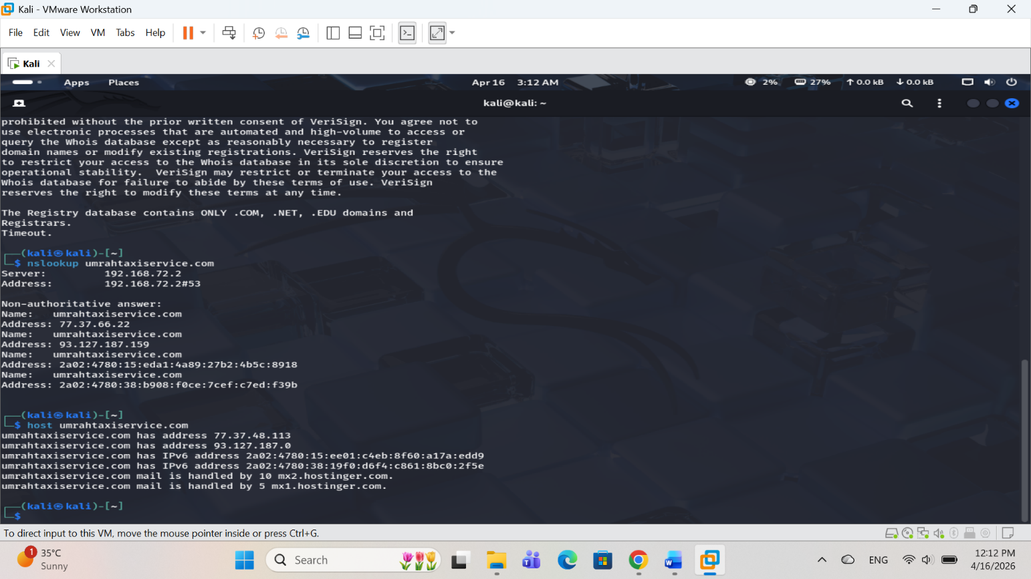
- What emails or subdomains were found?
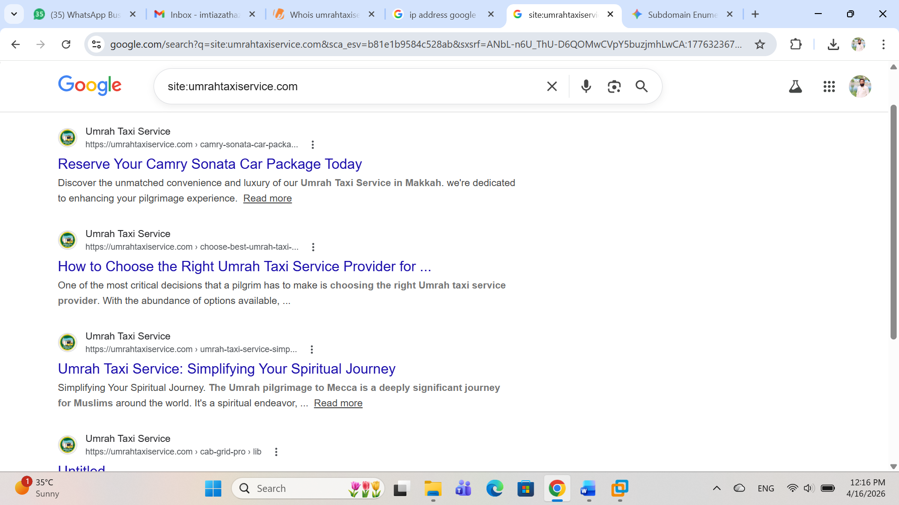
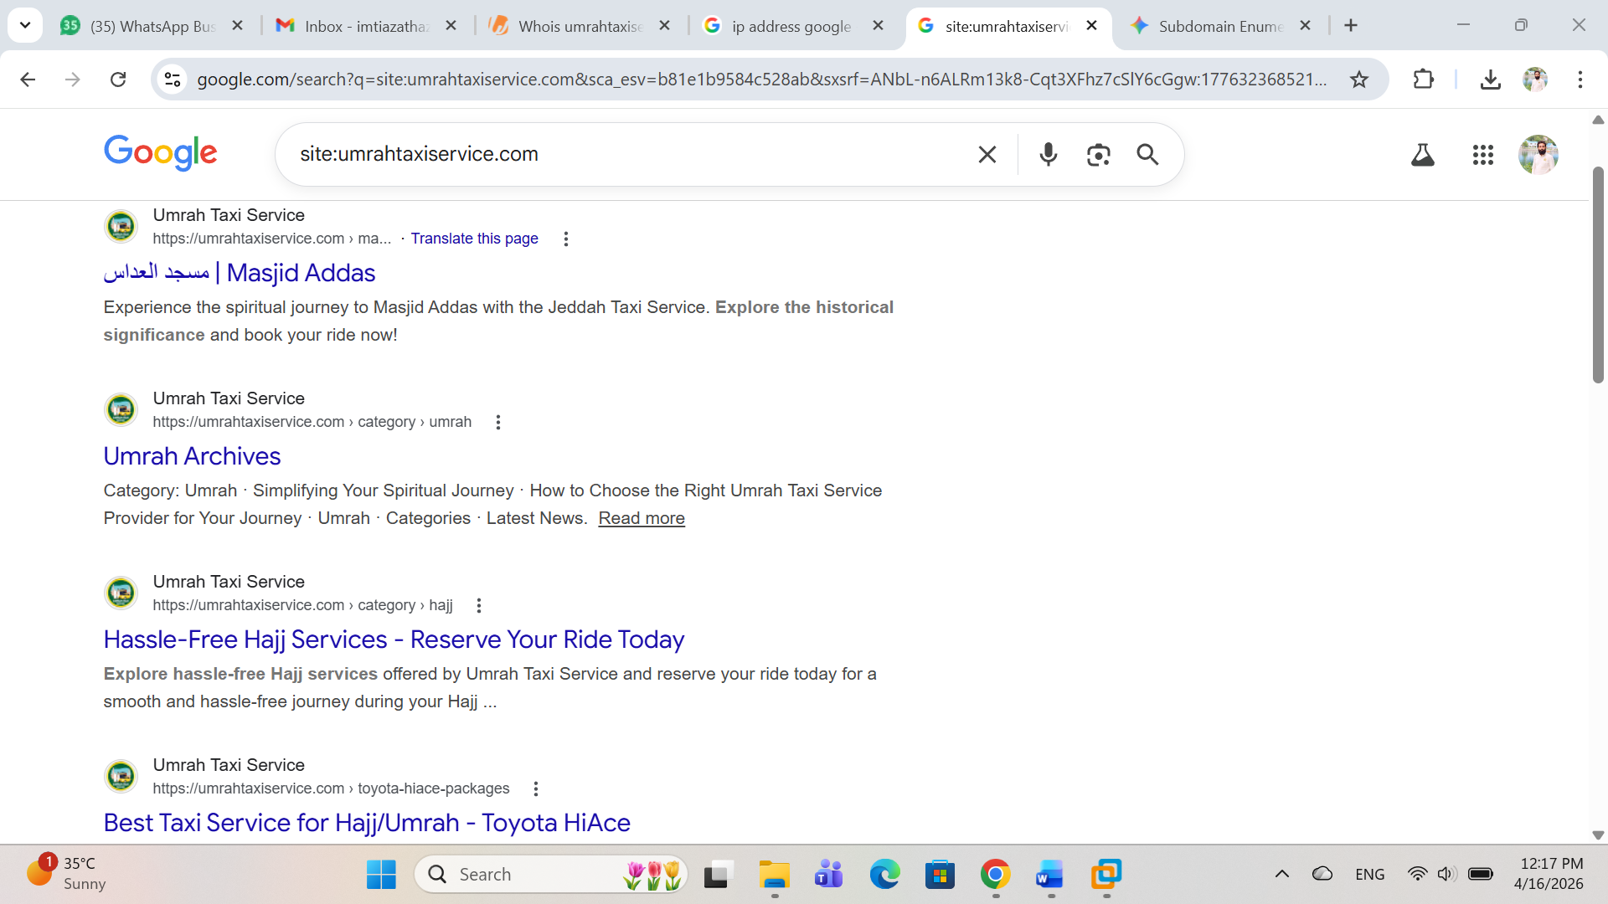
- What ports/services are exposed on Shodan?
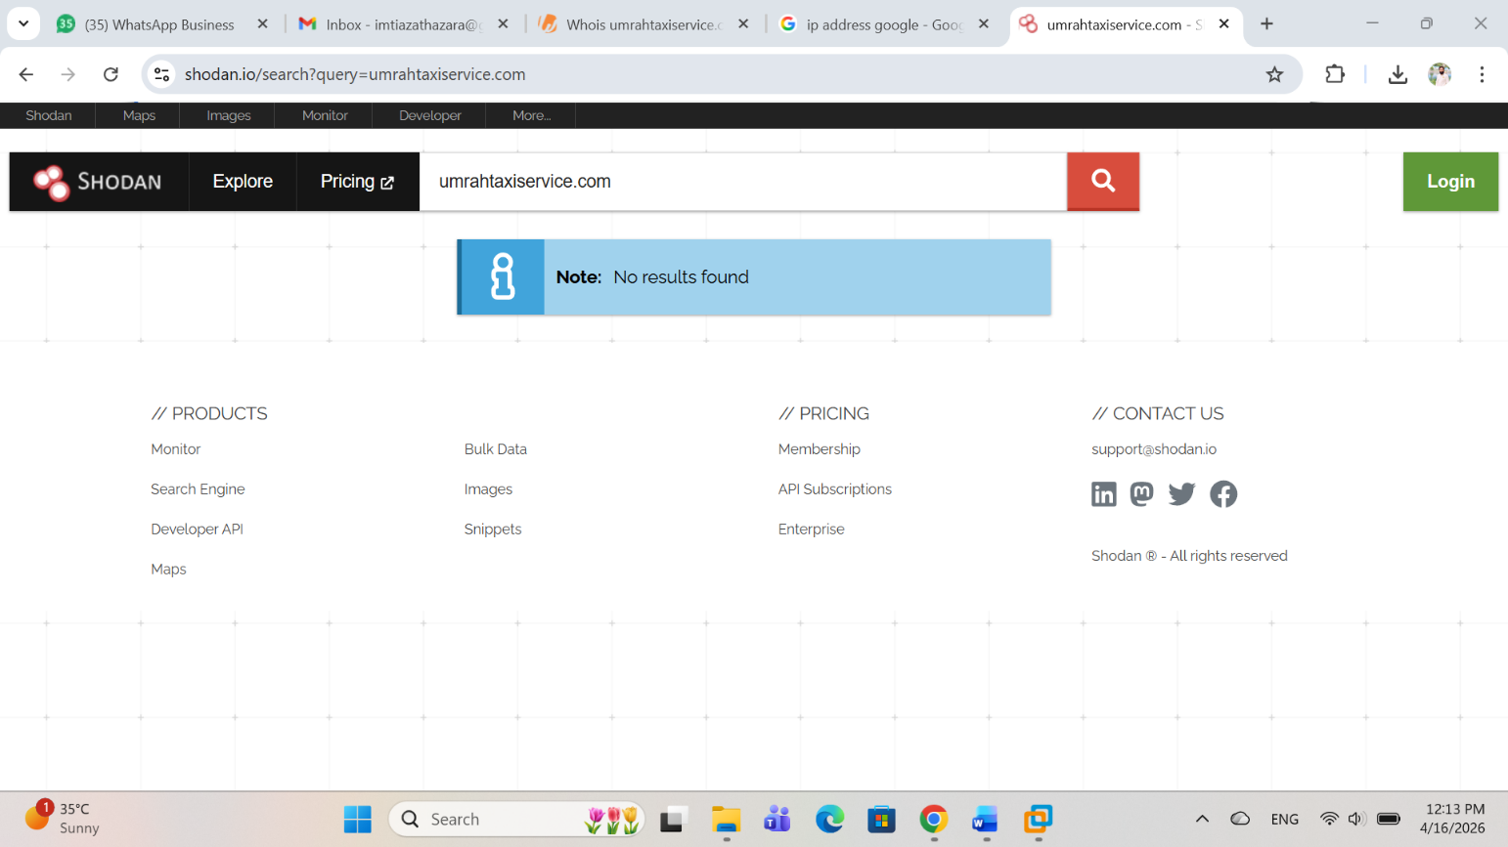
- Any suspicious indicators?
Searched using different methods including nmap scripts and shodan.io search but couldn’t found any suspicious indicator.

